A

Project Report on

**RIP AND DHCP**

Submitted in partial fulfillment of completion of the course

Advanced Diploma in IT, Networking and Cloud

Submitted by:

**Bhupesh Ther**

|  |  |  |
| --- | --- | --- |
| IBM-Logo - Chicago Innovation | DGT introduces high end diploma courses - digitalLEARNING Magazine | Edunet Foundation-Delhi- CSR Organization profile |

Year 2023

**Abstract**

**Abstract**

This documentation outlines the design and implementation of a Routing Information Protocol (RIP) combined with Dynamic Host Configuration Protocol (DHCP) network infrastructure. The integration of these two fundamental networking protocols aims to create a dynamic and efficient network environment suitable for small to medium-sized enterprises (SMEs) or similar network environments.

The RIP protocol is utilized for routing within the network, providing a means for routers to exchange routing information and make data forwarding decisions. On the other hand, DHCP is employed for automating IP address allocation and network configuration for devices connecting to the network. By combining these protocols, we achieve a network that not only efficiently routes data between devices but also simplifies the management of IP addresses and other network parameters.

|  |  |
| --- | --- |
| **Table of contents** | **Pages** |
| Introduction to problem | 1 |
| Perpose Solution |  |
| Requirement |  |
| Implementation Details |  |
| Testing |  |
| References |  |

**Introduction to problem**

In today's rapidly evolving technological landscape, businesses and organizations are increasingly reliant on network infrastructure to support their operations. However, many encounter challenges in balancing the need for efficient data routing and the complexities of network configuration and IP address management. To address these challenges, there is a need for the design and implementation of a Routing Information Protocol (RIP) combined with Dynamic Host Configuration Protocol (DHCP) network that can provide seamless data routing while simplifying the management of IP addresses and network configurations.

**Inefficient Network Routing**: Current network infrastructures often struggle with routing data efficiently between devices, leading to latency, bottlenecks, and decreased network performance. There is a need for a routing protocol like RIP to improve data flow within the network.

**Manual IP Address Management:** Traditional IP address allocation and management require significant manual intervention, which can result in IP conflicts, configuration errors, and increased administrative overhead. DHCP can help automate this process, but integrating it effectively with the network is a challenge.

**Security Concerns**: Ensuring the security of network communications and the integrity of IP address assignments is crucial. Implementing RIP and DHCP in a secure manner is a non-trivial task that requires addressing potential vulnerabilities and threats.

**Scalability**: As organizations grow, their network requirements also expand. The network design should be scalable to accommodate additional devices and services without causing disruptions or performance degradation.

**Proposed Solution**

To address the challenges outlined in the problem statement and create an efficient and manageable RIP + DHCP network, we propose the following solutions:

**RIP Implementation:**

* Deploy RIP (Routing Information Protocol) as the routing protocol of choice within the network.
* Configure routers to exchange routing information using RIP.
* Implement RIP version 2 (RIPv2) for support of CIDR and enhanced security features.

**DHCP Integration:**

* Set up DHCP servers strategically within the network to automate IP address assignments.
* Configure DHCP scopes, address reservations, and options to manage IP address allocation efficiently.
* Implement DHCP relay agents where necessary to extend DHCP services across multiple subnets.

**Security Measures:**

* Implement access control lists (ACLs) and firewall rules to secure network traffic.
* Employ authentication mechanisms for RIP to prevent unauthorized routers from participating in routing updates.
* Regularly update and patch network devices and servers to mitigate security vulnerabilities.

**Documentation and Training:**

* Create comprehensive network documentation, including network diagrams, configurations, and troubleshooting guides.
* Train network administrators and support staff on network management and troubleshooting procedures.

**Backup and Recovery:**

* Establish backup and recovery procedures for DHCP server configurations and network device configurations to minimize downtime in case of failures.

**Testing and Validation:**

* Conduct thorough testing of the RIP + DHCP network before deploying it in a production environment to identify and resolve any issues.

**Requirements**

**Hardware Requirement :-** Operating System computer/ laptop(window/ Linux)

**Software Requirement :-** Cisco Packet tracer (latest version more comfortable )

**Design Documentation**

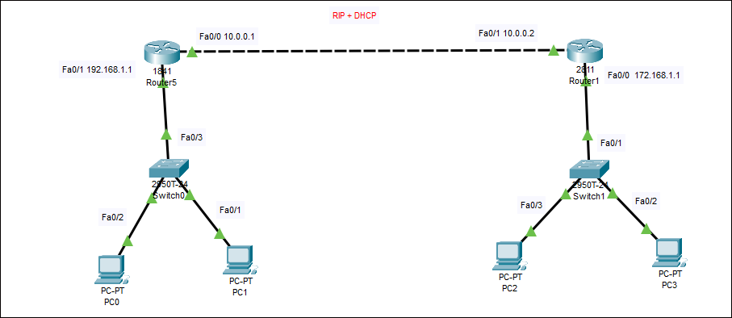

**Implementation Details**

Step 1 :- Open you pc and come on task bar and in the search bar type cisco packet tracer

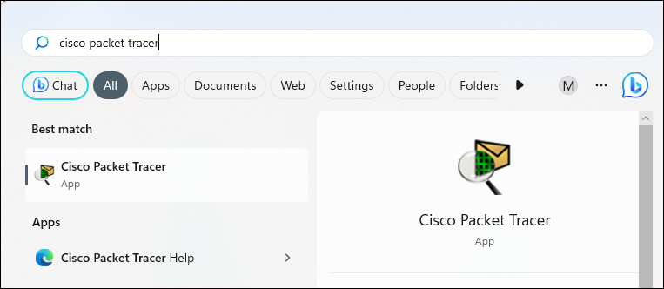

Step 2 :- Now your packet tracer ready to work

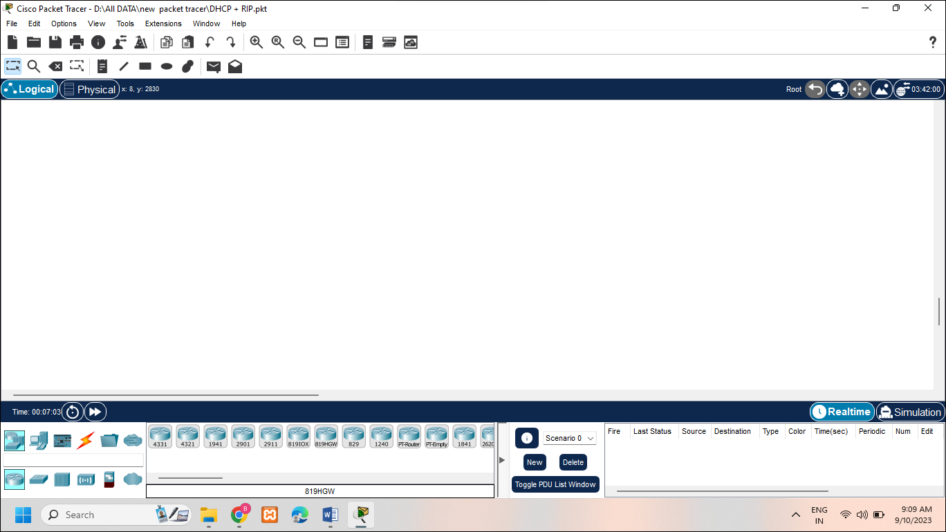

Step3 :- Now ready your topology to configure rip and dhcp

* 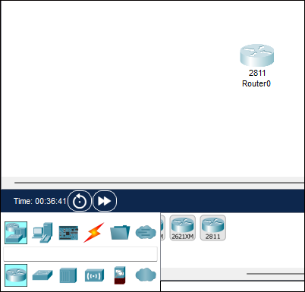 Take to router ( need 2 router for configure rip )

1. 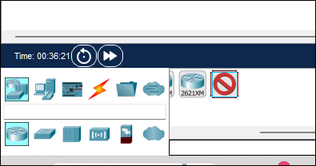 2)

Step 4 :- now take cable (auto choose ) and join on router to another

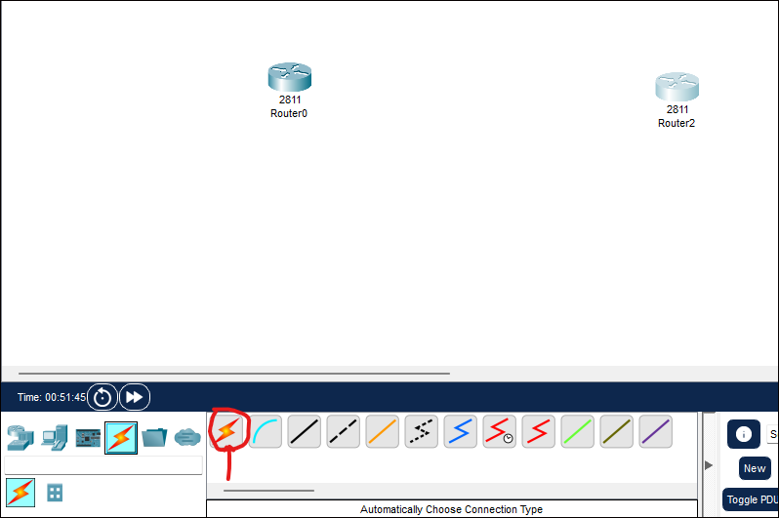

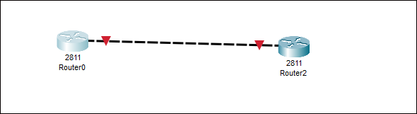

Step 5 :- Now take 2 switch

* take 2 switch and next connect to router with the help of cable (auto choose cable)

1. 2)

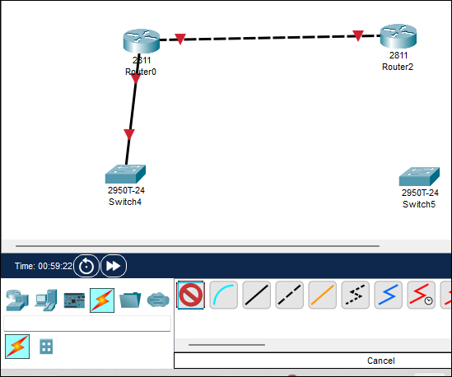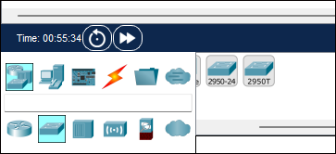

Step 6 :- Now take 4 computer and connect 2 pc to both switch .

1. 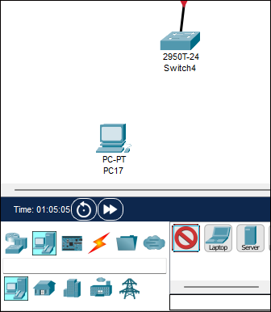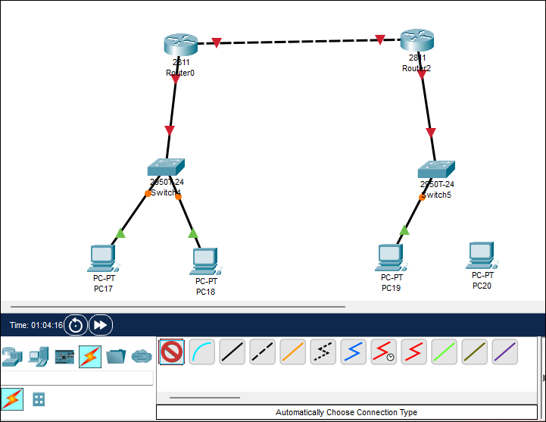 2)

Step 7 :- Now your hardware structure ready need to configure.

* First configure routers(configure on cli mode )
* For open router click on the router
* now router open and check whose cable connect with which device
* Now come on the cli mode of router

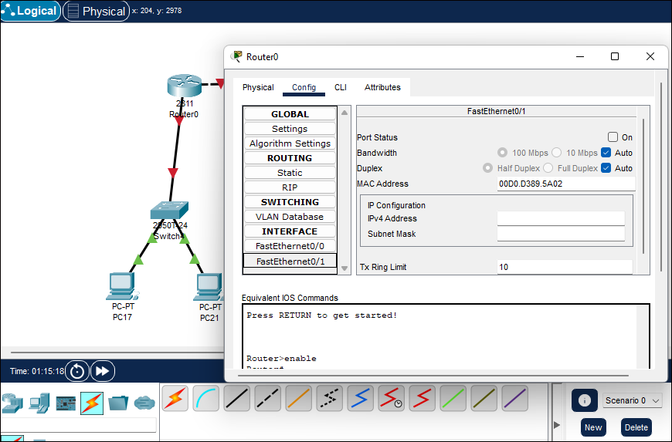

* Asking for

Would you like to enter the initial configuration dialog? [yes/no]:

Says no

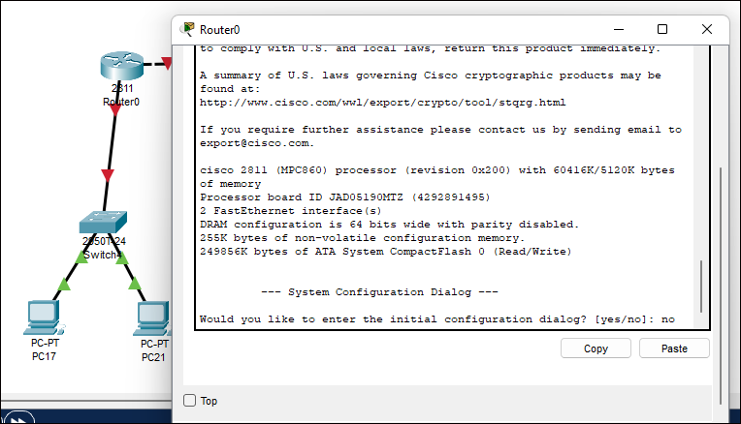

* Now configure router-1 give ip address to port fa/0 and fa/1for that run command in given below

**Router - 1**

Router#enable

Router#configure terminal

Enter configuration commands, one per line. End with CNTL/Z.

Router(config)#int fa0/0

Router(config-if)#ip address 10.0.0.1 255.0.0.0

Router(config-if)#no shutdown

Router(dhcp-config)#exit

Router(config-if)#int fa0/1

Router(config-if)#ip address 192.168.1.1 255.255.255.0

Router(config-if)#no shutdown

Router(dhcp-config)#exit

Router(config)#ip dhcp pool bt_1

Router(dhcp-config)#net 192.168.0.1 255.255.255.0

Router(dhcp-config)#default-router 192.168.1.1

Router(dhcp-config)#exit

Router(config)#

Router(config)#router rip

Router(config-router)#ver 2

Router(config-router)#net 192.168.1.1

Router(config-router)#net 10.0.0.1

Router(config-router)#end

Router#

**PC_1 :- (same process in the PC_2)**

* Now come on the router-1 network pc
* Go on the desktop next go on ip configure
* And choose dhcp (now ip address auto field)

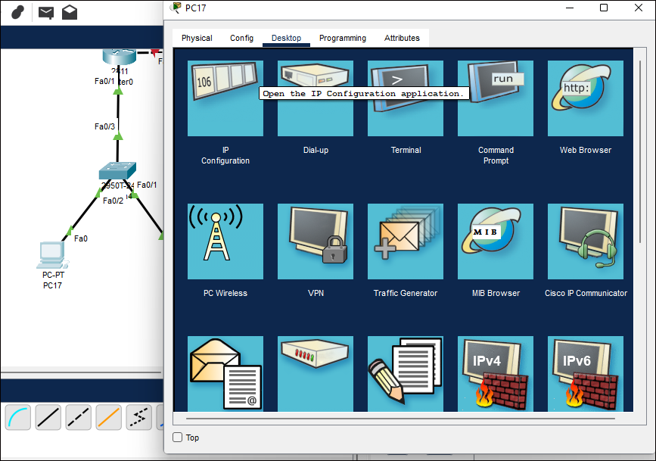

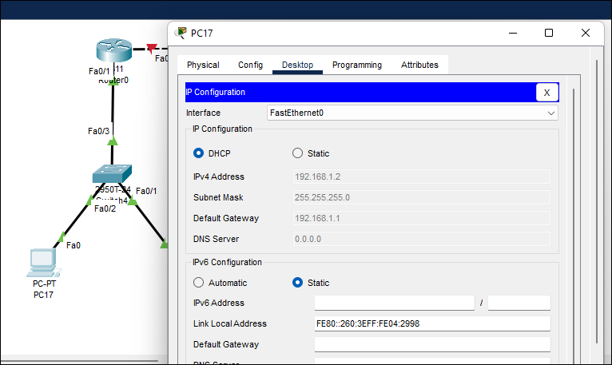

**Router-2 :-**

Now Need to configure Router_2 for the click on router and open it and check out which cable connect on which port next come on the cli mode of router

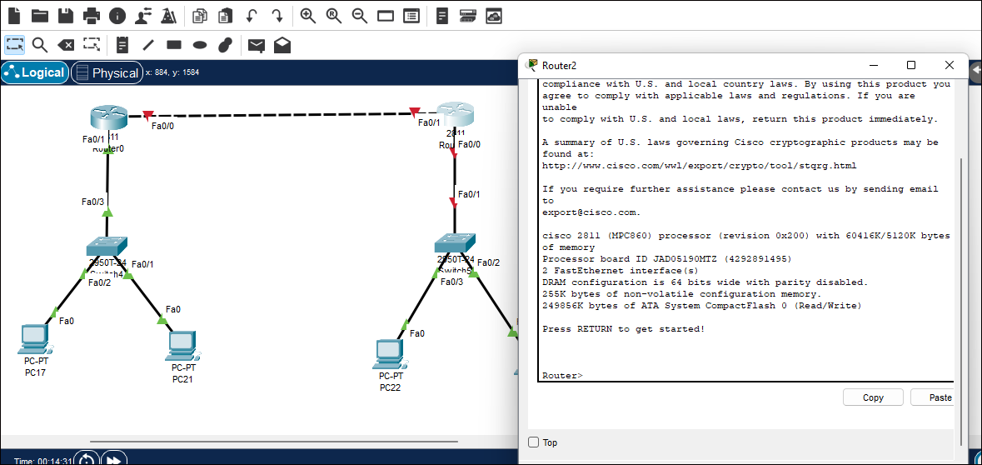

Now run this command

Router>

Router>enable

Router#configure t

Router(config-if)#int fa0/1

Router(config-if)#ip address 10.0.0.2 255.0.0.0

Router(config-if)#no shutdown

Router(dhcp-config)#exit

Router(config-if)#int fa0/0

Router(config-if)#ip address 172.168.1.1 255.255.0.0

Router(config-if)#no shutdown

Router(dhcp-config)#exit

Router(config)#

Router(config)#ip dhcp pool bt_2

Router(dhcp-config)#network 172.168.1.1 255.255.255.0

Router(dhcp-config)#network 172.168.1.1 255.255.0.0

Router(dhcp-config)#default-router 172.168.1.1

Router(dhcp-config)#end

Router#

Router#confi t

Router(config)#router rip

Router(config-router)#version 2

Router(config-router)#network 10.0.0.0

Router(config-router)#network 172.168.0.0

Router(config-router)#end

Router#

Router#wr

Building configuration...

[OK]

**PC_3:- Now configure PC-3**

* Click on the pc
* Next go on the config
* Now click on dhcp network ( fill up auto ip address )

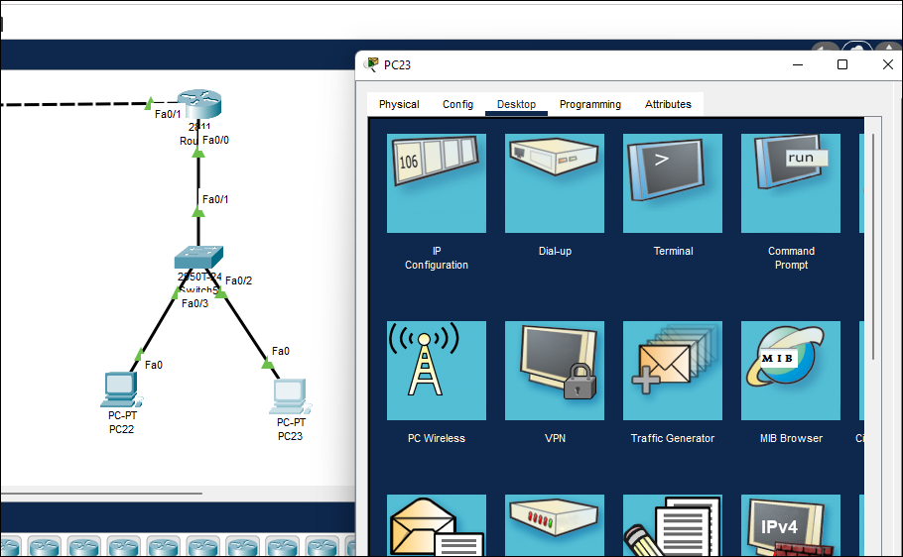

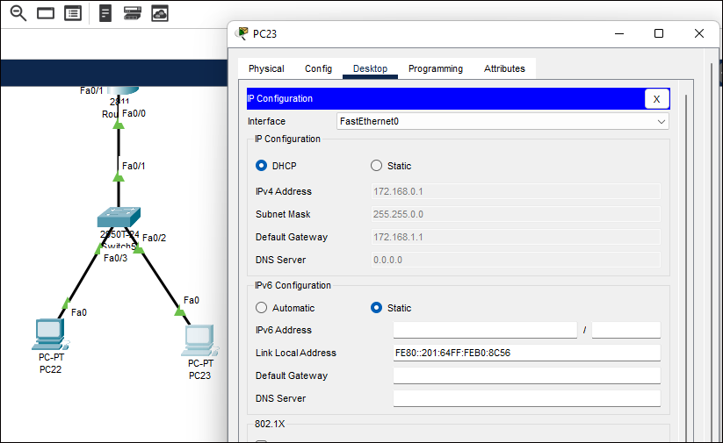

Final output Ready :-

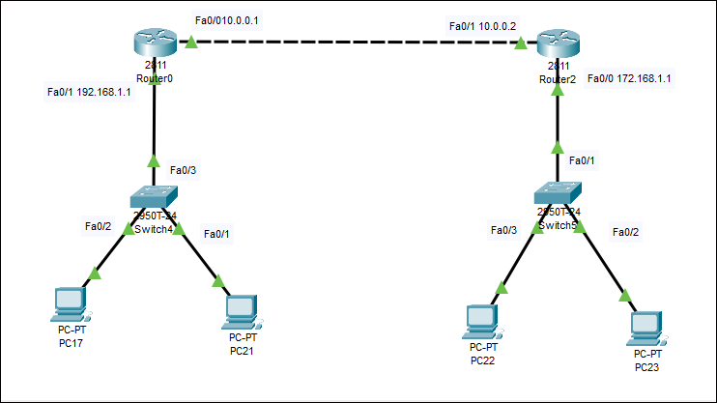

Testing :-

Step 1:- Test Configure your network

Try to sent msg on network to another

* Attempt 1 :- Router-2 to sent msg PC-1

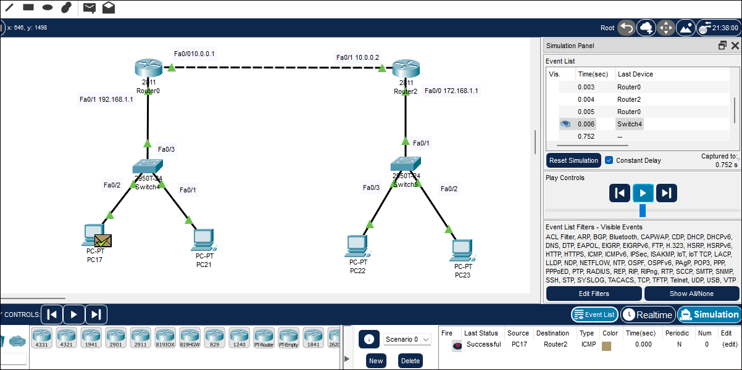

* Attempt 2 :- Router-1 to sent msg on pc-3

In the right side down corner show details about msg sending successfully

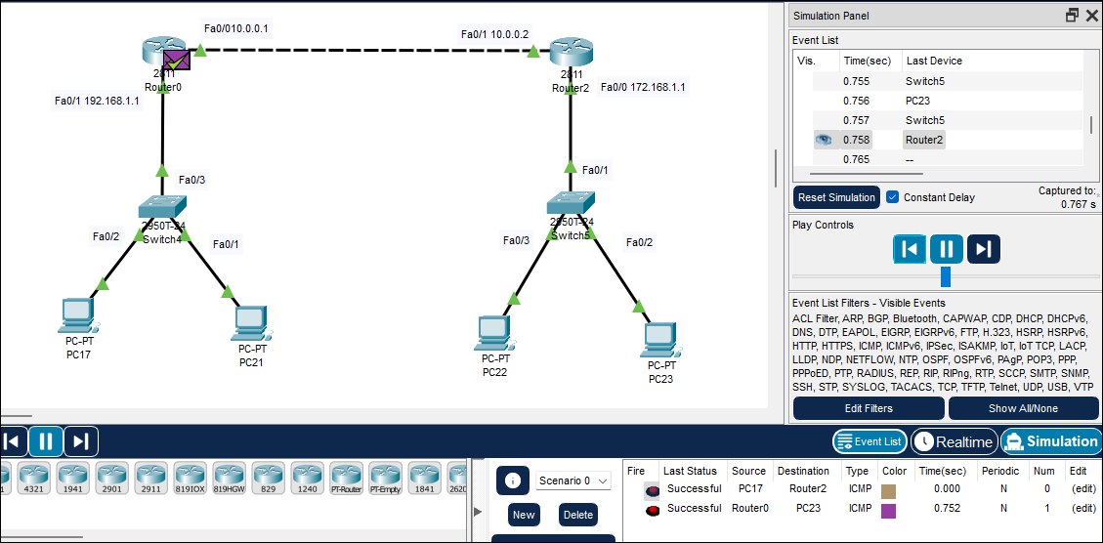

Attempt 3 :- send msg from PC-1 to PC-4

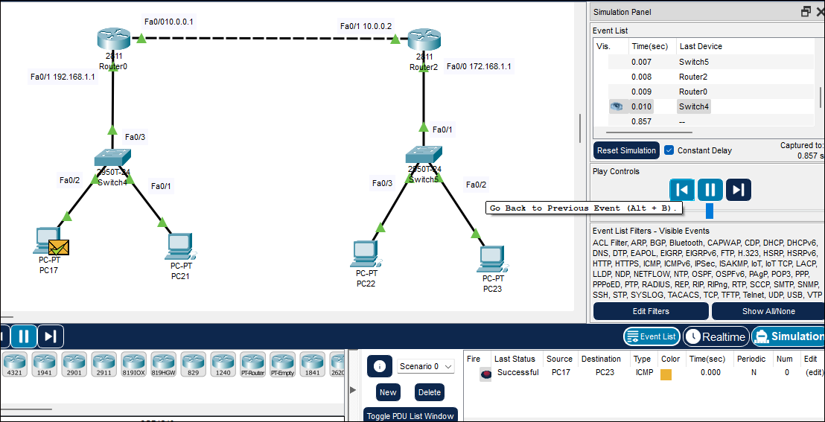

Your rip + dhcp nework configure sueccessfully